FILE PERMISSIONS IN LINUX

3.LINK COUNT
Link count is the total number of names referring to the same file data.
Link counts are:
- File---------------------> (1)
- Directory-------------> (2)
- Parent directory----> (3)
Note:
- Directory link count is not always 2 or 3
- It increases when subdirectories are created
HARDLINK: - (ln)
1.These links have the actual file content (original file content) but it points out to the
data which is stored it on the disk
2.link count increases by 1
3.inode number is same (ls -i)
4.cannnot create hardlink of directory
5.if u write anything on the original file it will automatically replicate to the hardlink
file
6.its file type is normal file.
example:
ln file1 file2 ------------------------> i have created the file2 as a hardlink file for file1

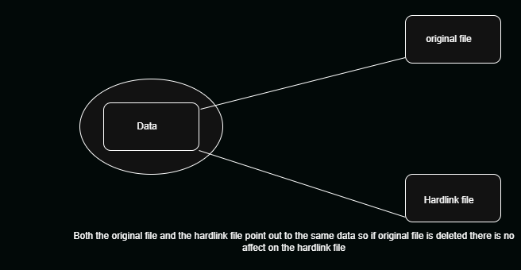

SOFTLINK: (ln -s)
1. Used to create a shortcut file (pointer) to another file
2.link count does not increase
3.inode number is different (ls -i)
4.can create softlink of file as well as directory
5.if u delete the original file, softlink file colour changes from blue to red
6.its file type is link file.
example: -
ln -s file1 file2 ----------------------> i have created the file2 as a shortcut file for file1

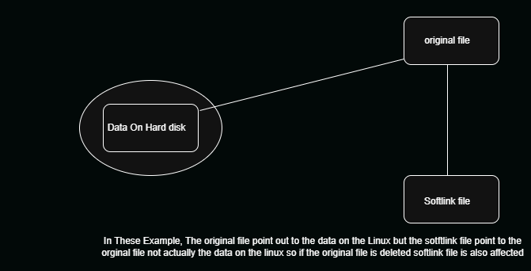

INODE VALUE (number): -
1.inode simply means a index node a uniq number assigned to every file in Linux
2. It stores information (metadata) about the file, not the file name.
3.example: - ls -i filename

INODE contains:
- File size
- File permissions
- Owner (user ID)
- Group ID
- File type
- Timestamps (created, modified, accessed)
- Link count

Example: - Adhar number of a person, name change but the number remain same

4.OWNERSHIP
ownership means basically who owns the file and the group of that file

1.To change owner: -
chown Linux file

2.To change the group: -
chgrp Linux file

3.To change both owner and group: -
chown linux:linux file

Example: -
1.touch new
ls -l
-rw-r--r-- 1 root root 0 Apr 11 16:53 file
2.chown mayur:mayur file
ls -l
-rw-r--r-- 1 mayur mayur 0 Apr 11 16:53 file

SCENARIO

IF SUPPOSE THE USER IS CREATED BUT DIRECTORY NOT ACCESSIBLE OF USER

- adduser user1
- su – user1
su: warning: cannot change directory to /home/user3: Permission denied
This message is shown once a day. To disable it please create the
/Home/user1/.hushlogin file.
-bash: /home/user1/.bash_profile: Permission denied
- exit
- ls -ld /home/user1
- chown -R user1:user1 /home/user1
- chmod 755 /home/user1
- ls -ld /home/user1
drwxr-xr-x 2 user1 user1 4096 Apr 18 14:14 /home/user1
- su – user1
Successfully accessing the files

